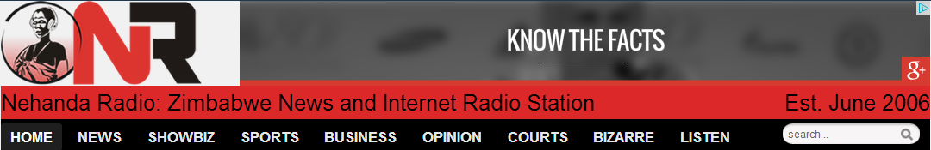
Advertising Rate Card
Rank | Ad Type | Size | Placement | Monthly
1 | Side Banner | 160x250 | Entire site | £150
2 | Top leader banner | 728x90 | Entire site including homepage | £750
2 | Side sky scrapper | 300x600 | Entire site | £650
3 | Category Banners | 600x90 | Homepage only | £400
4 | Side Banner | 300x250 | Entire site including homepage | £300
5 | Side Banner | 300x90 | Entire site including homepage | £200
6 | Audio Jingle | Before every hourly bulletin | One month | £500

Our Facebook fan page now has 112 700 fans and growing
https://www.facebook.com/NehandaRadio
Our twitter account now has 13 300 followers and growing
https://twitter.com/NehandaRadio
We also have a Google powered mailing list with 25 000 subscribers who receive news every morning.

Are you tempted?
All advertising queries can be e-mailed to adverts@nehandaradio.com
Or call our hotline: +44-777-855-7615

